Benha University |  | Faculty of Computers & Informatics
2nd Term (May 2017) Final Exam  Class: 3rd Year Students  Subject: Database Management Systems  Course Code: DBA 372 |  | Date: 7/6/2017  Time: 3 Hours  Examiner(s): Dr. Walaa Medhat

Answer the following questions:

Question No. 1 [10 Marks]

a) Choose the correct Answers (5 Marks):
1. Which is not a function of a DBA?
(A) Defining the database constraints (B) Authorizing access to the database
(C) Defining the database transactions (D) None of the above

2. Which is in the DBMS-dependent design process?
(A) Requirement analysis (B) Conceptual design (C) Transaction implementation (D) None of the above

3. Which is not a function of a DBMS?
(A) Optimization and execution (B) data recovery and concurrency
(C) data security and integrity (D) none of above

4. Which statement is true?
(A) A relation can have different values at different times.
(B) A relation is inherently a specific set of values.
(C) A tuple corresponds to a column in a table.
(D) none of above

5. Which is not one of transaction's ACID properties?
(A) automicity (B) concurrency (C) isolation (D) durability

6. Which of the following is false?
(A) A relation can have multiple candidate keys.
(B) Key constraint means the primary key cannot have null values.
(C) A candidate key can uniquely identify a row.
(D) An enterprise key whose value is unique across all relations.

7. What does the following SQL statement do? select name from student where city = 'Hsinchu'; ?
(A) Retrieves the name of all students who live in Hsinchu.
(B) Retrieves all students who live in Hsinchu from the student table.
(C) Retrieves all cities whose name is Hsinchu from the student table.
(D) None of the above

8. Concurrency Control lock granulaty have levels:
(A) Database-level lock
(B) Table-level lock
(C) Page-level lock
(D) Row-level lock
(E) All of the above.

9. Referential Integrity means
(A) The Foreign Key represents a reference to the matching Primary Key
(B) Every value of a given Foreign Key is required to appear as a value of the matching Primary Key
(C) There is no requirement for the Foreign Key to be a component of the Primary Key

10. The INTERSECT operation returns
(A) A relation consisting of all tuples from a specified relation that satisfies a specified condition
(B) A relation consisting of all tuples that remain as tuples in a specified relation after specified attributes have been eliminated
(C) A relation consisting of all tuples appearing in both of two specified realtion

b) Define the following terms: attribute domain, relation schema, relation instance, relation cardinality, and relation degree.

Question No. 2 [13 Marks]

A database used in an order-entry system is to contain information about customers, items, and orders. The following information is to be included. For each customer: customer number (unique), “ship-to” addresses (several per customer), Balance, Credit limit, Discount. For each order: Heading information: customer number, ship-to address, date of order. Detail lines (several per order): item number, quantity ordered. For each item: Item number (unique), manufacturing plants, Quantity on hand at each plant, Stock danger level for each plant, Item description. For internal processing reasons a “quantity outstanding” value is associated with each detail line of each order. This value is initially set equal to the quantity of the item ordered and is (progressively) reduced to zero as (partial) shipments are made.

- Design and Draw an entity-relationship diagram ER for the order-entry database.
- Map the ER diagram for the order-entry database into a relational Database schema.
- Draw the referential diagram and specify all primary keys and foreign keys.

Question No. 3 [15 Marks]

Consider a company database with the following relation schemas where primary keys are underlined:

employee (first_name, last_name, id_no, birthday, gender, salary, supervisor_id_no, department_no)
department (department_name, department_no, manager_id_no)
department locations (department_no, department_location)
project (project_name, project_no, project_location, department_no)
works on (id_no, project_no, hours)

Use SQL to write the following queries:
- Find the names of employees who are directly supervised by 'Avril Lavigne'.
- For each department, retrieve the department name, number of employees in that department, and the average salary of employees working in that department.
- For each department whose average employee salary is more than $50000, retrieve the department name and the number of employees working for that department.
- Remove employees whose salary is more than $100000.
- Increase the pay of all employees in the 'Research' department by 5%.
Question No. 4 [15 Marks]
The following figure shows an ERD of an Internet Sales Model.

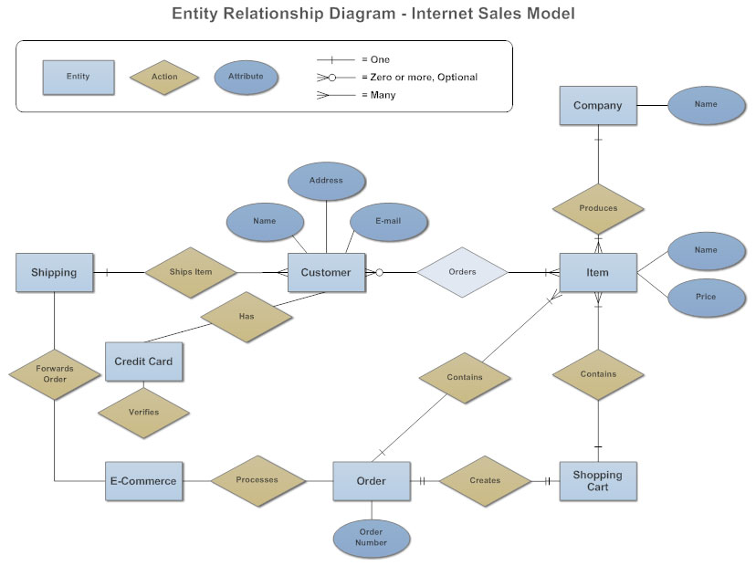

- Write the business rules that explain that model.
- Transform the ERD to a set of relations and develop a relational schema.
- Write the SQL statements required to create these relations, including appropriate versions of all primary and foreign key integrity constraints.
- What recommendations would you make regarding opportunities for denormalization?

Question No. 5 [12 Marks]

Consider the following relation schema LIBRARY show below and the following set G of functional dependencies in LIBRARY:

Card_no | Bk_id | Br_name | Br_phone | Bk_Title | Author | Pb | Pb_address | Date_out | Due_date

The following abbreviations are used BK=Book, Br=Borrower, Pb= Publisher

G:= {{Card_no, Bk_id {Br_name, Bk_Title, Date_out, Due_date}, Bk_id {Bk_title, Author, Pb}, Card_no {Br_Name, Br_phone}, Pb Pb_address}

- What normal form the relation in? Explain your answer.
- Apply normalization until you cannot decompose the relation further. State the reason behind your decomposition.

GOOD LUCK

